# Photoshop logo 1 analysis

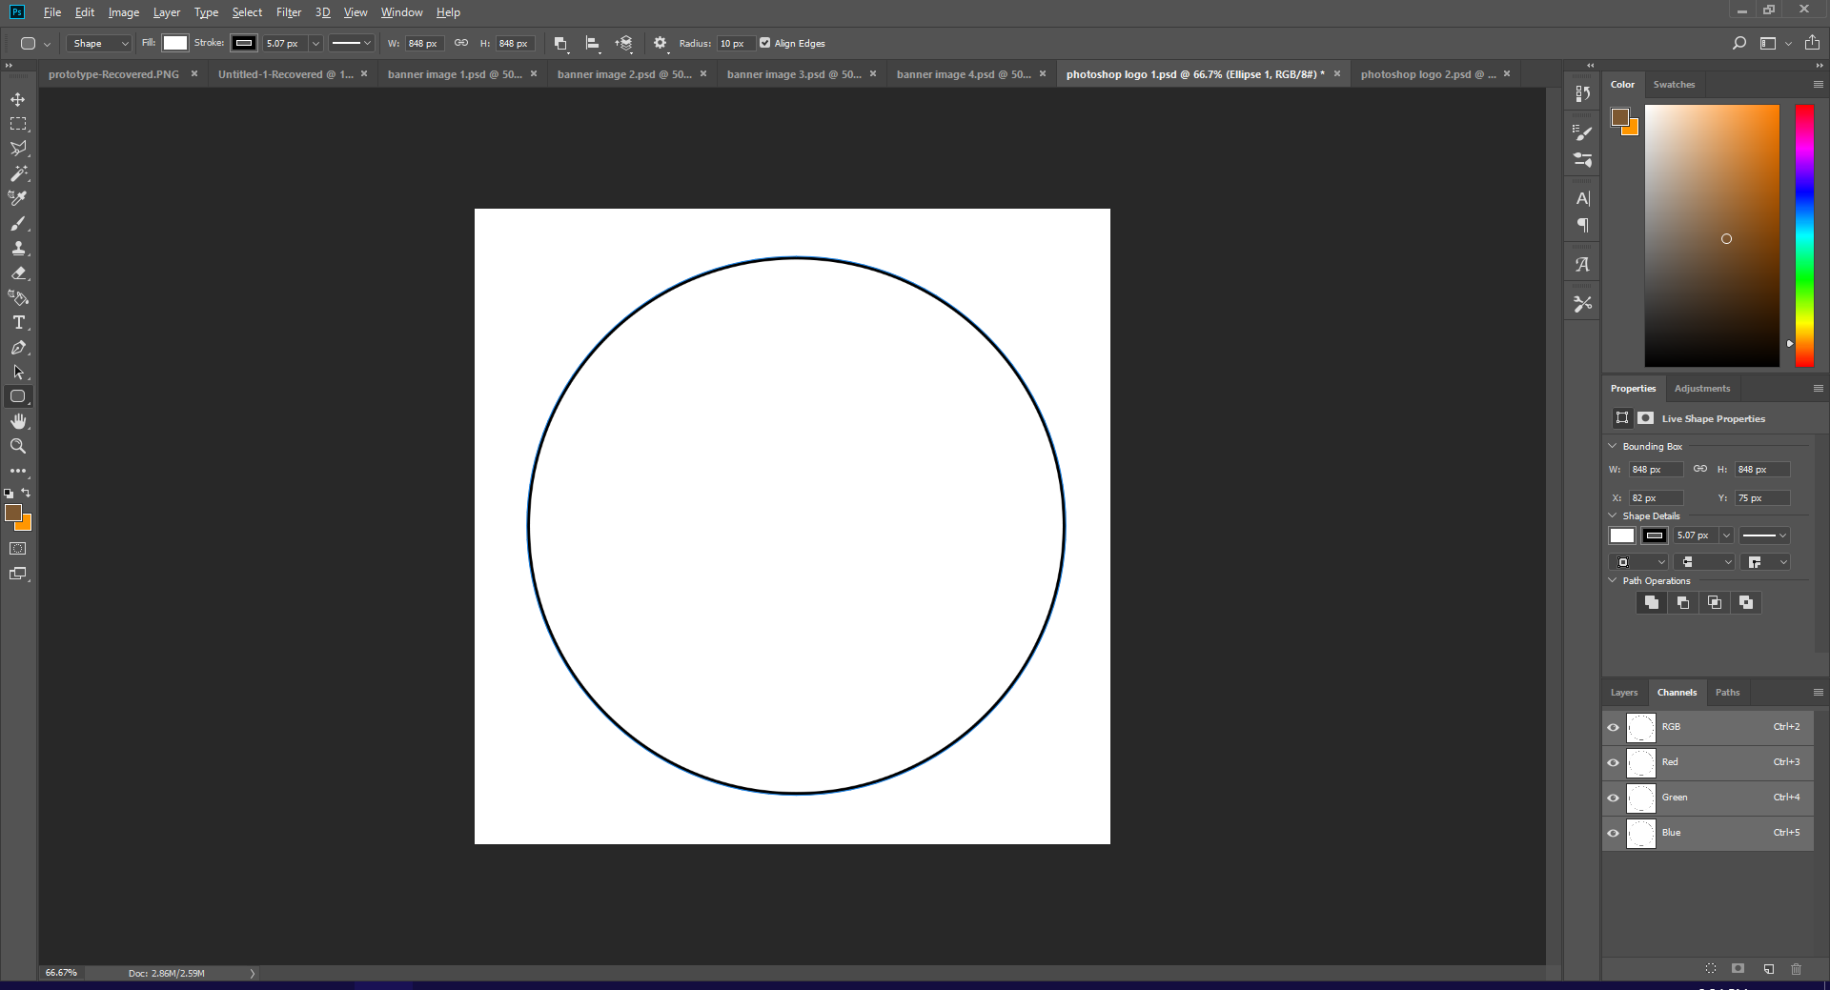

For this logo I wanted it to be enclosed within a circle. Therefore, I first needed to create said circle, which I did by using the **circle shape tool.**

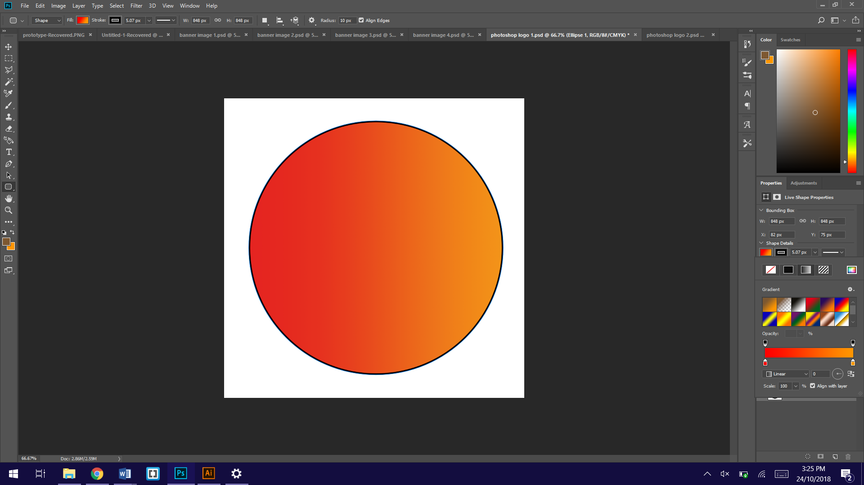

I then gave the circle some colour. I decided to go with a similar gradient used on other graphics done within this unit, which I did by using the **gradient tool**, to create continuity throughout and show that the icons, banners and logo are all connected together. If this was being done for a real company, all the graphics would need to be similar to show that they were created for the specific campaign, and it means the audience won’t get them confused with older or newer graphics in the future.

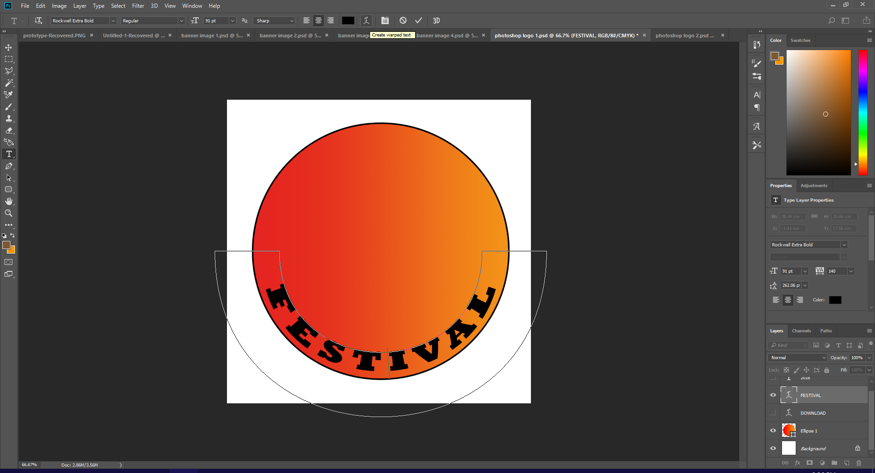

To create text that raps around the circle, I first needed to create the text, using the **text tool**. I then used the **warp function** and curved the text until it fitted well within the circle.

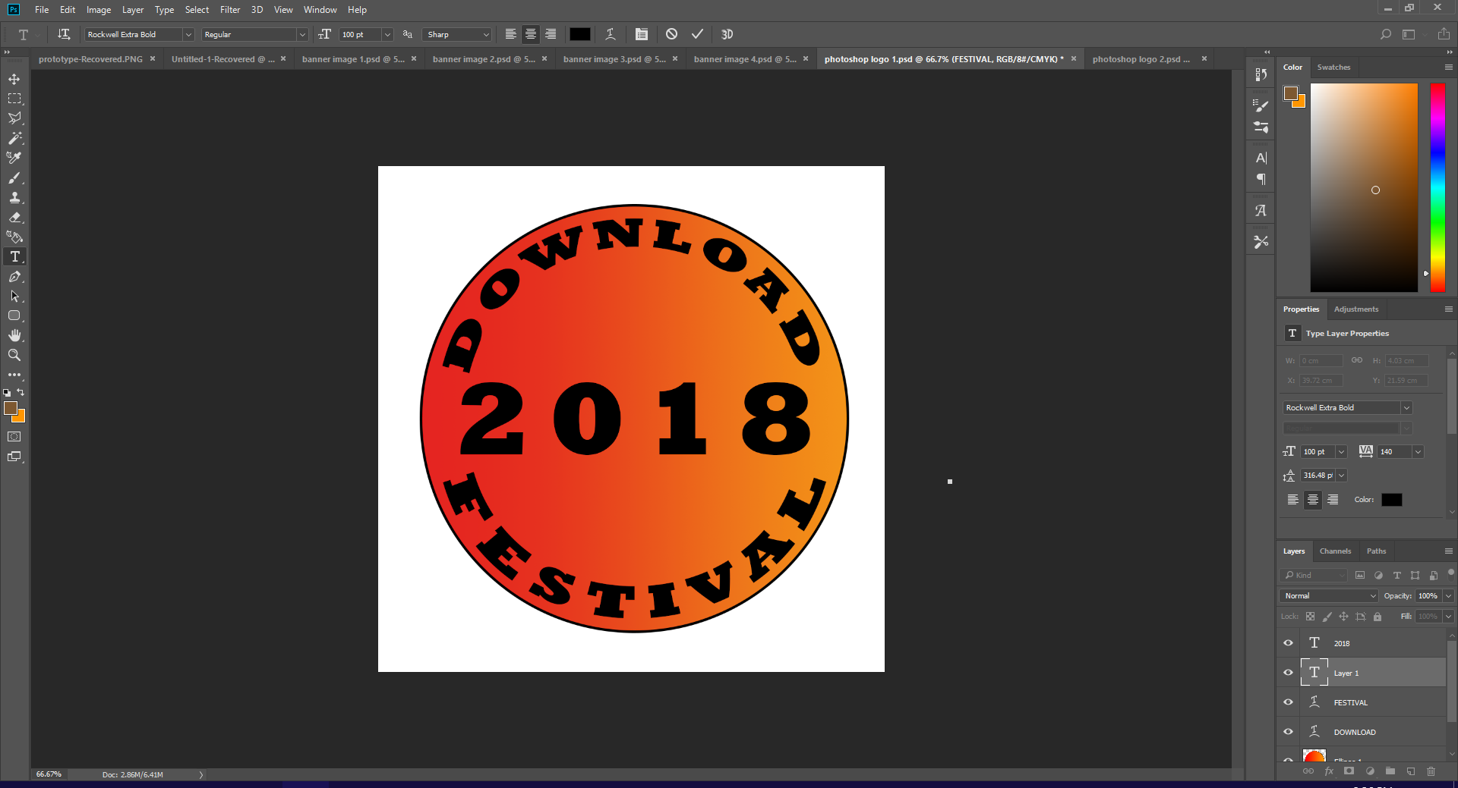

I repeated this for the text above, and then put the year the festival is across the middle. This also shows the viewer what year of festival this is advertising which would make it clearer to the audience whether this was older or newer. This links back to the continuity of the graphics, because if they see one thing in a particular style and know what year that’s for, then it will be easy to link the other graphics to the same year.

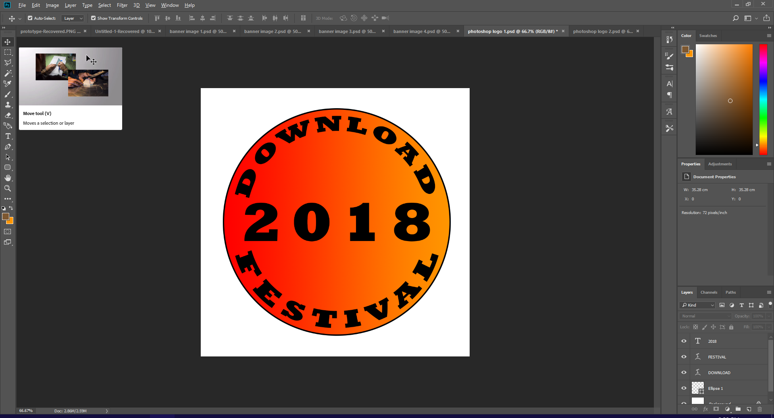

Personally, I don’t like this graphic very much. the mix between the font choice, the gradient and the circle in this instance makes the logo seem out dated, and it just doesn’t really fit the theme of a rock festival. The colours in the background do target the correct audience but grouped with that font doesn’t give it a very rock or metal feel. The font in this use case would suit a more country style of music, which isn’t played at download. However, the actual colours on the gradient I do like, and I think that the red and the orange suit the target audience well as they could represent fire, which could be linked to the music itself but also to the festival, which sometimes uses flamethrowers on stage for added effect. I think that I will use this gradient on future logos.